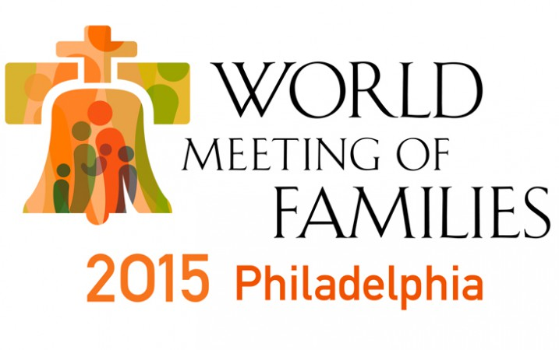
THE PEOPLE’S POPE AND
OUR FIVE DAYS IN PHILADELPHIA

When Charley told me a couple of months ago that he woke up that morning and felt a very strong call to register the Emmaus Ministry for Grieving Parents as an Exhibitor at the World Meeting of Families 2015 (WMOF2015) , I thought he was more than a little off, as this would not be an inexpensive venture. Ours is a very small ministry with absolutely no discretionary funds.
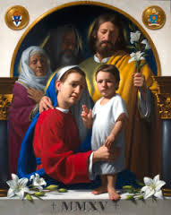
Fast forward to last week when we left New England early Monday morning to travel to Philadelphia to exhibit and share information about the Emmaus Ministry to anyone who would listen. Because of our grace-filled experiences in the Diocese of Wheeling-Charleston WV, our goal at the WMOF2015 was to meet as many diocesan Marriage and Family Life Coordinators that we could. Our hope was to interest them in the ministry and begin discussions of the many ways of bringing it to their broken parents.
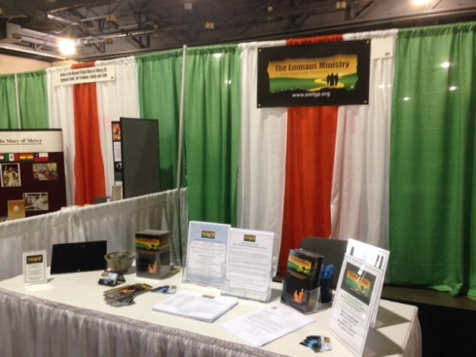
On the way to the forum…something extraordinary happened. We were only on the fringes of Papa Francis’ visit to the United States, but we were profoundly moved by it. Having grown up in nearby Lancaster County, both Charley and I know Philly as a tough and gritty place to be—and, for us, not very welcoming. What we experienced last week was completely different.
Pope Francis wasn’t even on American soil yet, but his presence in Philly when we arrived was palpable, evidenced by the huge smiles on so many faces, all types of people wearing clothing carrying images not only of Francis, but other saints, and the splendor of international Catholicism everywhere. It was very joyous and very different.
And this was only Monday. Pope Francis was due to arrive on Saturday. As we progressed through Tuesday, Wednesday and Thursday, the overall feeling of happiness and oneness in the city continued to grow exponentially each day.
Stopping by a sub shop to get a Philly cheese steak on Thursday, the customer behind us proclaimed to everyone there, “Is this the best Pope ever or what?! I want marinara sauce because that is what the pope eats!” It was a very special time in the city indeed.
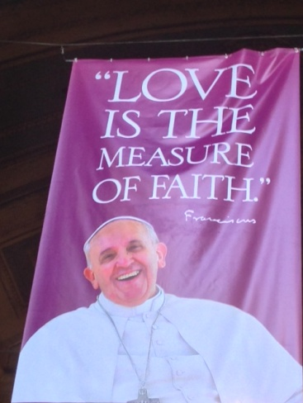
Over the five days we were there at our booth in Exhibit Hall C, we did meet a steady stream of interested Marriage and Family Life Coordinators, as well as deacons, priests, sisters, Bereavement Coordinators, publishers, and directors of complementary ministries. They came to us from dioceses all over the United States—actually, the world, including people from Bermuda, Nigeria, Singapore, and Viet Nam.
At our booth, we had a banner depicting our logo and our mission, “Serving the Spiritual Needs of Grieving Parents.” It was interesting to watch the reaction of people walking by. Many read the message, averted their eyes, and continued walking. Others, in the opposite extreme, almost stopped in their tracks, came up to us, and said…
”We need this; we want this.”
“How can we make this happen in our diocese?”
“I was meant to stop here.”
“Do you have any DVD’s or training guides?”
And so many said…
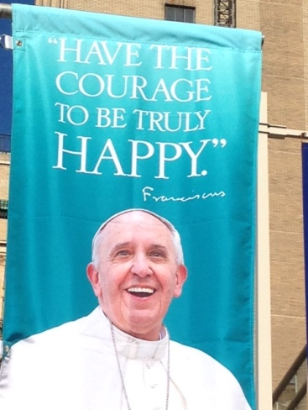
“Thank you for offering this ministry. It is so needed.”
We also had grieving parents stop by…as well as friends of grieving parents. Several times during the conference, we took off our Exhibitor hats and literally companioned these heartbroken parents and friends… all the while believing that we were meant to be in this place, at this time, for a reason.
Thursday night right before closing we learned that, because of extremely heightened security, the Exhibit Hall would close a full day earlier than planned. We were very disappointed because we were hoping to interact with Bishops who began to arrive in town in preparation for their meeting with Pope Francis on Sunday.
However, we left Philadelphia with a beautiful, renewed sense of and pride for Catholicism –and a feeling of oneness with others, thanks to the People’s Pope and his wonderful smile.
One commentator said, “Celebrities receive the light of adulation and take it in to buoy themselves up; Pope Francis takes the light of adulation and immediately reflects it back to us in his ubiquitous smile and actions —and that is why we are all so fascinated and moved by him.” He is who we aspire to be. Far from the world of bombastic American politicians, Papa Francis is very real. The contrast is astounding.
While we were not there physically for his visit to the WMOF2015, participating in the Conference leading up to his visit and experiencing the excitement and pure joy that his visit spread throughout the city of Philadelphia and the entire world, was a true gift.
We pray that the ripple effect of this wondrous visit will continue to nourish the souls of all of us who need it most. We ask for guidance in where The Emmaus Ministry for Grieving Parents is being led… and the strength to do whatever we all need to do to make it happen. Please join us, and, as Pope Francis says, “Pray for us!”
