“Into the Light” Mass for Those Affected by Suicide
Dispels Some of the Darkness

“Too many of us panic in the dark.
We don’t understand that it is a holy dark
And that the idea is to surrender to it…
And journey into the real, true light,
The light of Christ.”

In recognition of September as Suicide Prevention Month, on Saturday, September 17, the Emmaus Ministry of St. Anthony Shrine offered its Second Annual “Into the Light” Mass. It was a hot, muggy night, but those of us who came found much comfort and peace in the Eucharist that night.

Assisted by Deacon Chris Coccia, Fr. Joe Quinn celebrated the Mass for the intentions of all victims and family and friends affected by suicide. Mark Emery and the Arch Street Band provided music that was both lively and inspiring.

As they entered, worshipers were greeted by Emmaus Parent Companions who invited them to write the names of their Loved Ones affected by suicide on small cards. The names of each of the 26 Emmaus Ministry children who have died by suicide were included. These cards were then placed in the Emmaus Ministry prayer bowl. Later, along with the bread and wine, the names were presented as part of the Offertory of the Mass and placed in reverence on a table in front of the altar.
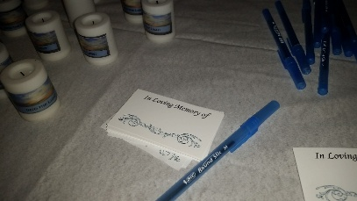
Each worshipper who stopped by also received small “Into the Light” votive candles. After his homily, Fr. Joe invited anyone with a candle to come forward and place it on the table along with names of their loved ones.

Fr. Joe’s homily was particularly comforting as he exhorted us to eliminate the “Conspiracy of Silence” that all too often hides and keeps secret the death of a loved one by suicide. He emphasized that the act of suicide is the result of an illness. An illness rooted in love, not malice.

“After a death by suicide, what do we do?” Fr. Joe asked. “We have a choice,” he said. “We can forever mourn the death or we can build on the melody of their lives and complete the goodness that they had started in life.”
“We don’t have a vaccination preventing suicide,” said Fr. Joe. “Treatments are not always successful. We don’t know how one gets this disease, but we do know that it is not as simple as we once thought,” he said.

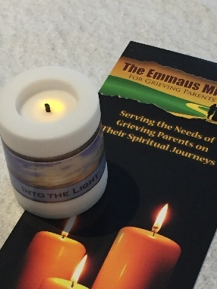
“We are called ‘Into the Light’ of true peace, kindness, love, and understanding throughout our lives,” Fr. Joe said. “We should not believe that we ‘lose’ those who have died…but we should choose to keep their love alive, for they now live in the fullness of God.”

“One day, we will be reunited with all of our loved ones, regardless of the manner of their death—and we will all live forever with God in that sacred place where there is no more suffering, illness, pain, or separation.”

Very comforting words from Fr. Joe.

To read Fr. Joe’s homily in full, see https://www.emfgp.org/9-17-16-fr-joe-quinn/.

After Communion, the Arch Street Band offered a beautiful musical meditation with the always moving, “Go in Peace:”
GO IN PEACE
There will be no more darkness / There is no more
night, no more night / There will be no more sadness /
Only joy and light, joy and light / Lift your eyes beyond
the hills / And see the dawn / There is beautiful mercy /
In the arms of the Holy One.
Refrain:
Go in peace, God be with you, Go in peace, be at rest /
With the saints and the angels / Now you are free / Go
in peace.
See, the Father is waiting / With a robe of white, purest
white / Go and feast at his table / With the bread of life,
bread of life / Lift your heart, rejoice and sing/ For you
are home / Home at last and forever / In the arms of the
Holy One.

Refrain x2:
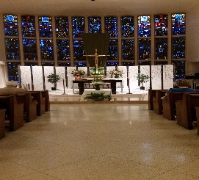
After Mass, worshippers were invited to approach the altar again and take their “Into the Light” candles home. Cards with names of loved ones affected by suicide will be burned and mixed with incense at a future Emmaus Ministry retreat.

If you are an Emmaus Parent who has attended a retreat—and would like to receive an “Into the Light” candle, please email up at diane@emfgp.org.

As we close a beautiful New England summer and look forward to a fruitful fall, this very special Mass, on a muggy September night, provided some much-needed spiritual nourishment to those of us who were there both in person and vicariously. Thank you, Holy Spirit.

