Serving the Spiritual Needs of Grieving Parents
St. Albert the Great-St. Francis Xavier
South Weymouth, MA
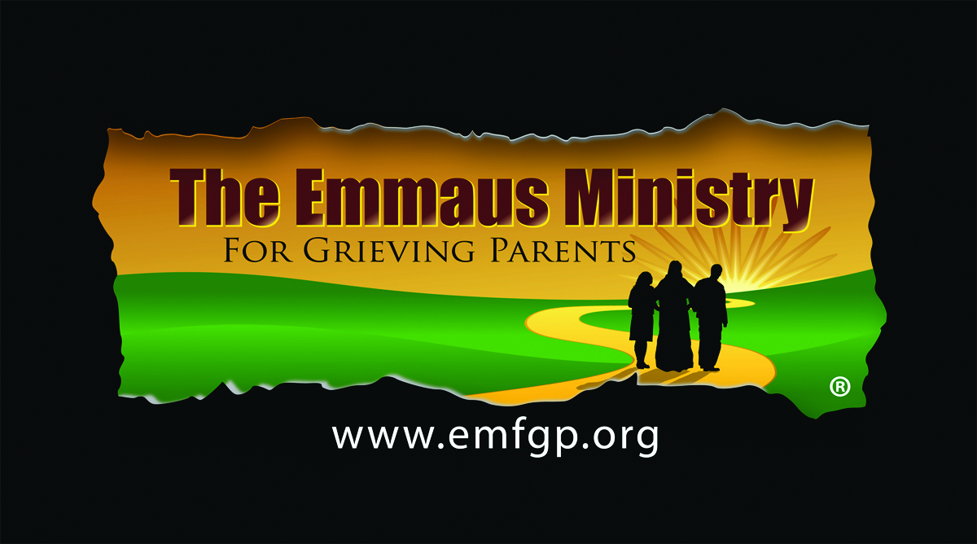

Saturday, January 14, 2017

A Spiritual One-Day Retreat for Parents Who Have Experienced the Death of
a Child of Any Age, By Any Cause—No Matter How Long Ago

Losing a child under any circumstances is horrific. Focusing on the spirituality of the grieving process can help tremendously. Just as He comforted His grieving disciples on the road to Emmaus, Jesus comforts us and we comfort each other in this very special ministry.

Join other grieving parents and parish spiritual leaders in a warm and loving place—
to think, to talk, to feel, and to pray. Find compassion, rest, and peace… at least for a time.
___________________________________________________________________

St. Albert the Great - St. Francis Xavier
Emmaus Ministry for Grieving Parents
ONE-DAY SPIRITUAL RETREAT
Saturday, January 14, 2017 from 9:30am-7:30pm

All Are Welcome!

Donation: $25 Individuals; $40 Couples
Scholarships are available.

For more information, call Patty, 781 337-1299; Betsy, 781 337-2171 ext 4, or
Diane or Charley, Paul’s Parents, at 617-542-8057.
Complete the Registration Form at www.emfgp.org
Or use the Registration Form on the other side of this flyer and mail to
The Emmaus Ministry for Grieving Parents at St. Francis Xavier-St. Albert
c/o 194 Bishops Forest Drive, Waltham, MA 02452
______________________________________________________________________________________

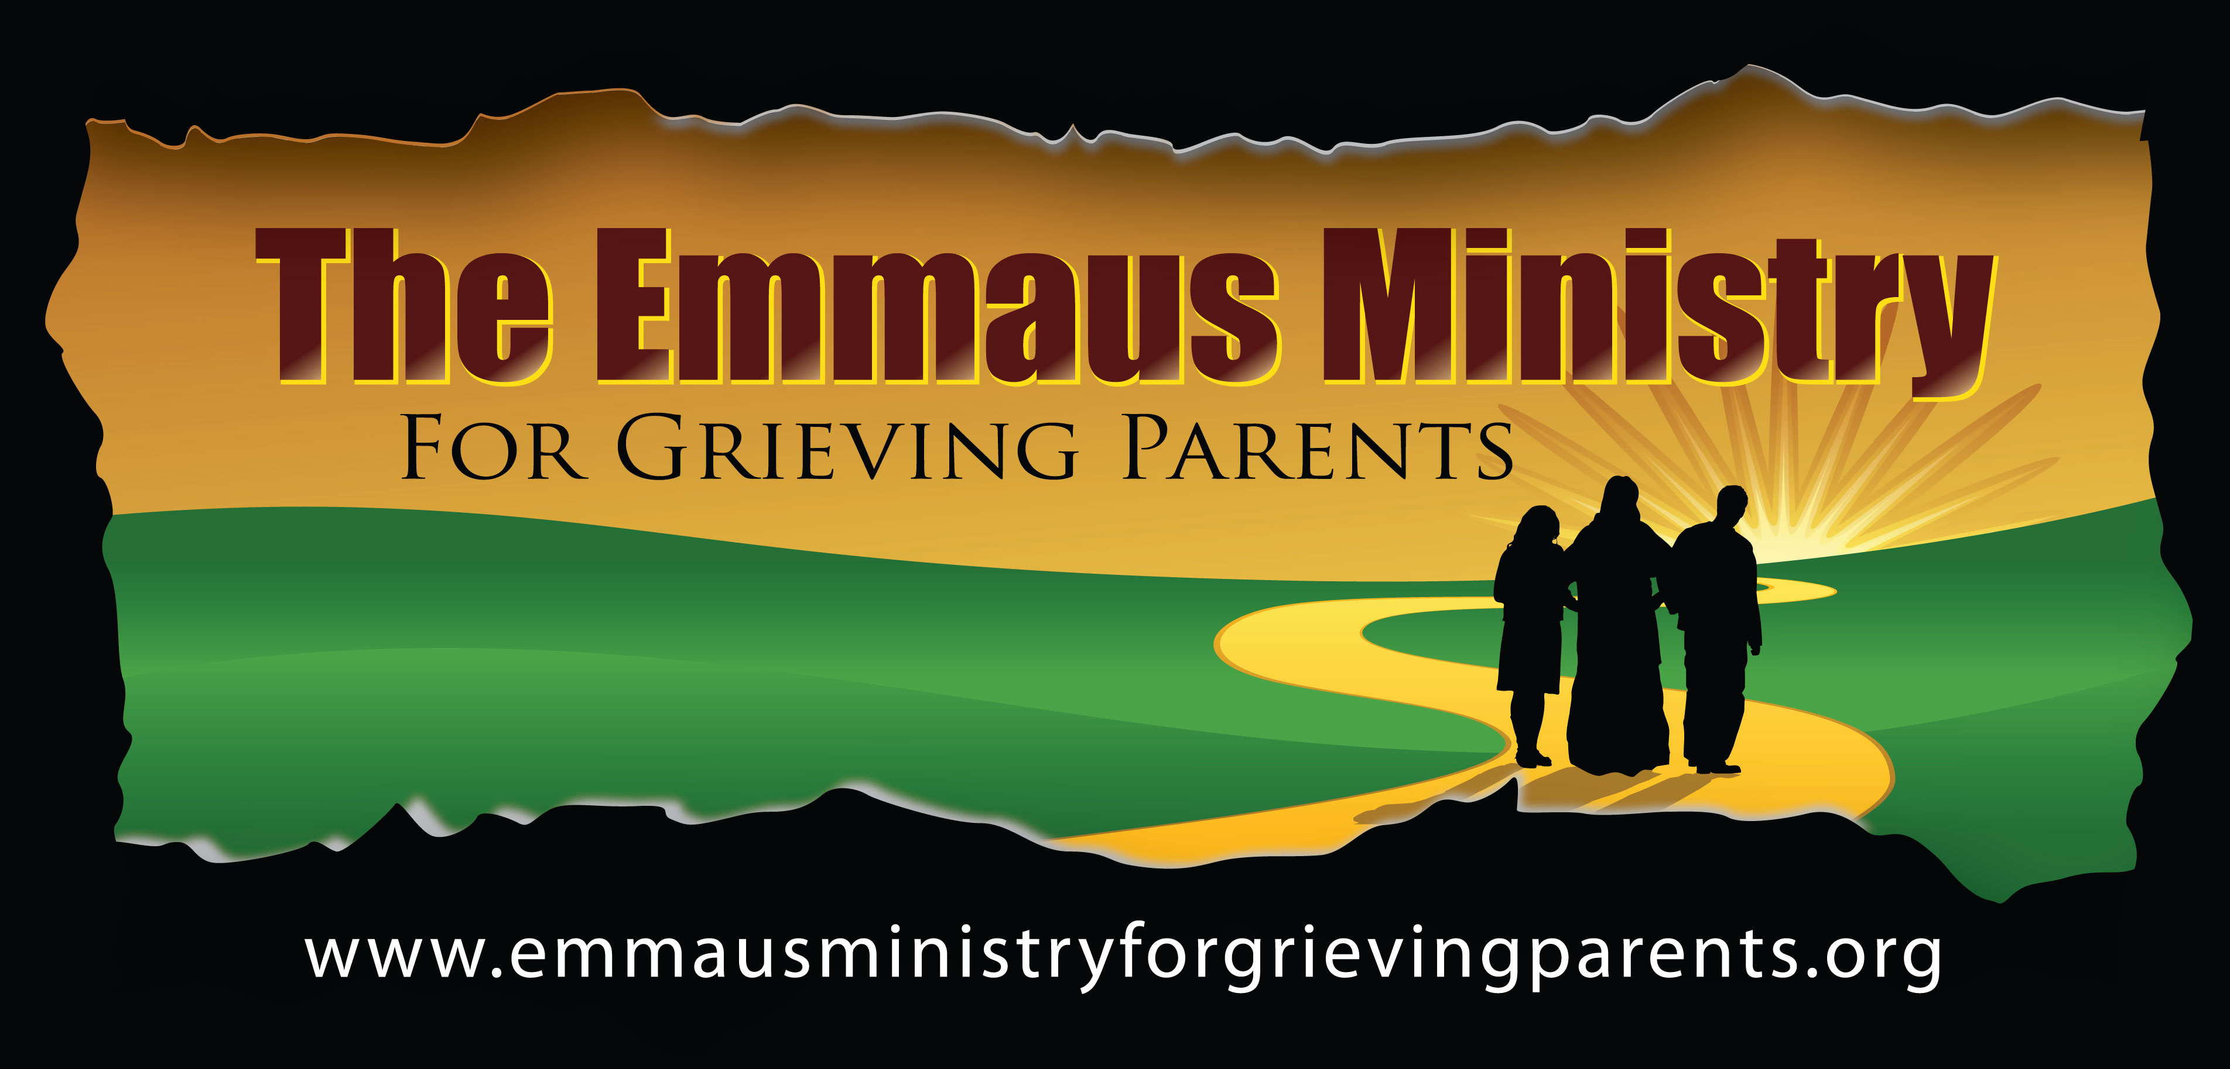
Name _________________________________________________________________
Address _________________________________________________________________
Street City State Zip
Phone __________________Email ___________________________________________
Please register me for the One-Day Emmaus Ministry Retreat at St. Francis Xavier Parish:
Individual @ $25 Total: $_______
Couple @ $40 Total: $________
Enclosed is my check made payable to The Emmaus Ministry for Grieving Parents.

Be sure to send this Registration Form and your check as soon as possible to
The Emmaus Ministry for Grieving Parents at St. Francis Xavier-St. Albert the Great
c/o 194 Bishops Forest Drive, Waltham, MA 02452
Or
Register and pay online at www.emfgp.org

NOTE: PLEASE BE SURE TO PRE-REGISTER BY JANUARY 10, 2017

Please cut here and mail as soon as possible
-------------------------------------------------------------------------------------------------------------------------------------------------------------------------
Also available through The Emmaus Ministry for Grieving Parents:
- One-Day Spiritual Retreats throughout the Archdiocese of Boston
- Weekend Spiritual Retreat at Miramar Retreat Center in Duxbury, MA the first weekend of November every year
- Monthly One-Hour Retreats at various locations throughout the Archdiocese of Boston.

See www.emfgp.org for specific times and locations for these programs.

To speak to someone who has attended our programs,
Call Patty, 781 337-1299, Betsy, 781 337-2171 x 4,
Or Diane and Charley, Paul’s Parents, at 617-542-8057.

REGISTRATION FORM
The Emmaus Ministry for Grieving Parents at
St. Francis Xavier-St. Albert the Great Collaborative
One-Day Spiritual Retreat
Saturday, January 14, 2017 from 9:30am to 7:30pm
234 Pleasant Street, South Weymouth, MA 02190

The Emmaus Ministry for Grieving Parents at St. Albert the Great- St. Francis Xavier Parish Collaborative
234 Pleasant Street, South Weymouth 02190 • (781) 337-2171 Parish
Info @ emfgp.org • www.emfgp.org

