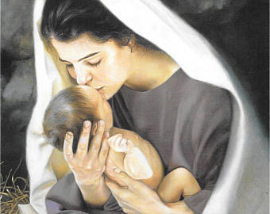

A Christmas-Eve Prayer
for Emmaus Ministry Parents
On that Holy Night,
Somehow... It happened.

Somehow...
God took a handful of humanity: Proud, petulant, passionate;
And a handful of Divinity: Undivided, inexpressible, incomprehensible,
And enclosed them in one small body.

Somehow...
The all-too-human touched the Divine
And was not vaporized.
To be human was never the same.

But forever thereafter,
Carried a hint of its close encounter with the perfect.
And forever thereafter,
God, to us, was never the same.
But carried a hint of the passion of the mortal.

If God can lie down in a cattle-trough,
Is any object safe from transformation?
If peasant girls can be mothers to God,
Is any life safe from the invasion of the eternal?

If all this could happen, O God,
What places of darkness on our earth
Are pregnant with light waiting to be born this night?

If all this could happen, O God,
Then you could be, and are, anywhere, everywhere,
Waiting to be born this night in the most unbelievable places…

Perhaps, even in our own hearts.

Amen.
--Ian Oliver

